**Class, Objects, and Pillars of OOPs**

1. Writing a program in Java to demonstrate the uses of classes and objects

**package** Pack3;

**public** **class** Dog {

String name;

String breed;

**int** age;

String color;

**public** Dog(String name, String breed, **int** age, String color)

{

**this**.name = name;

**this**.breed = breed;

**this**.age = age;

**this**.color = color;

}

**public** String getName()

{

**return** name;

}

**public** String getBreed()

{

**return** breed;

}

**public** **int** getAge()

{

**return** age;

}

**public** String getColor()

{

**return** color;

}

@Override

**public** String toString()

{

**return**("Hi my name is "+ **this**.getName()+ ".\nMy

breed,age and color are " + **this**.getBreed()+", " +

**this**.getAge()+ ", and"+ **this**.getColor() + ".");

}

**public** **static** **void** main(String[] args)

{

Dog scott = **new** Dog("Scott","papillon", 5, "black");

System.***out***.println(scott.toString());

}

}

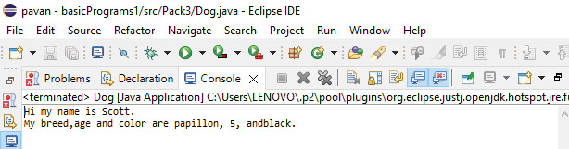

1. Writing a program in Java to demonstrate the uses of polymorphism

**package** Pack3;

**public** **class** Sum {

**public** **int** sum(**int** x, **int** y)

{

**return** (x + y);

}

**public** **int** sum(**int** x, **int** y, **int** z)

{

**return** (x + y + z);

}

**public** **double** sum(**double** x, **double** y)

{

**return** (x + y);

}

**public** **static** **void** main(String args[])

{

Sum s = **new** Sum();

System.***out***.println(s.sum(10, 20));

System.***out***.println(s.sum(10, 20, 30));

System.***out***.println(s.sum(10.5, 20.5));

}

}

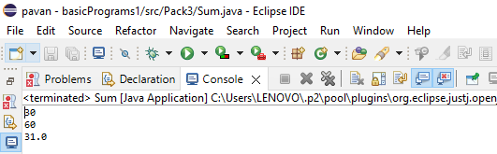

1. Writing a program in Java to demonstrate the uses of inheritance

**package** Pack3;

**public** **class** Bicycle {

**public** **int** gear;

**public** **int** speed;

**public** Bicycle(**int** gear, **int** speed)

{

**this**.gear = gear;

**this**.speed = speed;

}

**public** **void** applyBrake(**int** decrement)

{

speed -= decrement;

}

**public** **void** speedUp(**int** increment)

{

speed += increment;

}

**public** String toString()

{

**return**("No of gears are " + gear + "\n" + "speed of bicycle is " + speed);

}

}

**class** MountainBike **extends** Bicycle

{

**public** **int** seatHeight;

**public** MountainBike(**int** gear,**int** speed,**int** startHeight)

{

**super**(gear, speed);

seatHeight = startHeight;

}

**public** **void** setHeight(**int** newValue)

{

seatHeight = newValue;

}

@Override

**public** String toString()

{

**return** (**super**.toString()+

"\nseat height is "+seatHeight);

}

}

**package** Pack3;

**public** **class** Test {

**public** **static** **void** main(String args[])

{

MountainBike mb = **new** MountainBike(3, 100, 25);

System.***out***.println(mb.toString());

}

}

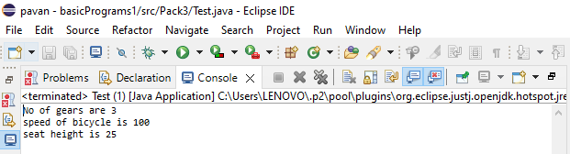

1. Writing a program in Java to demonstrate the uses of encapsulation

**package** Pack3;

**public** **class** Encapsulate {

**private** String Name;

**private** **int** Roll;

**private** **int** Age;

**public** **int** getAge()

{

**return** Age;

}

**public** String getName()

{

**return** Name;

}

**public** **int** getRoll()

{

**return** Roll;

}

**public** **void** setAge( **int** newAge)

{

Age = newAge;

}

**public** **void** setName(String newName)

{

Name = newName;

}

**public** **void** setRoll( **int** newRoll)

{

Roll = newRoll;

}

}

----------------------------------------------------------

**package** Pack3;

**public** **class** TestEncapsulation {

**public** **static** **void** main (String[] args)

{

Encapsulate obj = **new** Encapsulate();

obj.setName("Harsh");

obj.setAge(19);

obj.setRoll(51);

System.***out***.println("My name: " + obj.getName());

System.***out***.println("My age: " + obj.getAge());

System.***out***.println("My roll: " + obj.getRoll());

}

}

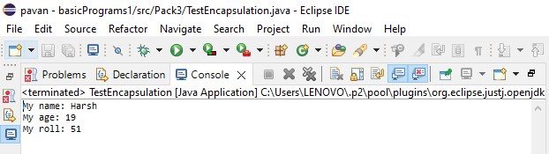

1. Writing a program in Java to demonstrate the uses of abstraction

**package** Pack3;

**public** **class** Test1 {

**public** **static** **void** main(String[] args)

{

Shape s1 = **new** Circle("Red", 2.2);

Shape s2 = **new** Rectangle("Yellow", 2, 4);

System.***out***.println(s1.toString());

System.***out***.println(s2.toString());

}

}

**package** Pack3;

**public** **class** Circle **extends** Shape {

**double** radius;

**public** Circle(String color,**double** radius)

{

**super**(color);

System.***out***.println("Circle constructor called");

**this**.radius = radius;

}

@Override

**double** area()

{

**return** Math.***PI*** * Math.*pow*(radius, 2);

}

@Override

**public** String toString()

{

**return** "Circle color is " + **super**.color + "and area is : " + area();

}

}

**package** Pack3;

**public** **class** Rectangle **extends** Shape {

**double** length;

**double** width;

**public** Rectangle(String color,**double** length,**double** width)

{

**super**(color);

System.***out***.println("Rectangle constructor called");

**this**.length = length;

**this**.width = width;

}

@Override

**double** area()

{

**return** length*width;

}

@Override

**public** String toString()

{

**return** "Rectangle color is " + **super**.color +

"and area is : " + area();

}

}

**package** Pack3;

**public** **class** Test1 {

**public** **static** **void** main(String[] args)

{

Shape s1 = **new** Circle("Red", 2.2);

Shape s2 = **new** Rectangle("Yellow", 2, 4);

System.***out***.println(s1.toString());

System.***out***.println(s2.toString());

}

}

